Diversification Effect: Stocks, Human Capital, and Real Estate

John L. Glascock
University of Cincinnati

Szu-Yin Hung
California State University-Bayside

Abstract
This paper incorporates human capital and real estate asset into the traditional mean-variance asset allocation model. The modified model suggests that people should hold risky securities with low covariance with his human capital. It explains why people do not hold identical market portfolios in reality. The model also suggests that people should buy a house with low comovement to his human capital and to his risky securities. If an individual has high return of his human capital, he should minimize his investment in risky securities and real estate asset.

Diversification Effect: Stocks, Human Capital, and Real Estate

I. Introduction
Mean-variance efficient model is an important paradigm in the finance literature. Sharpe (1964), Linter (1965), and Mossin (1966) develop a single-period mean-variance asset pricing model (hereafter referred to as the SLM model), which suggests that:
(a) all investors hold the same market portfolio which consists of every outstanding security, and (b) the expected return of a risky asset is determined by price of risk, the covariance of that risky asset with all other assets.

In reality, investors do not hold identical market portfolio. Many explanations have been offered to account for the difference between the theory and the practice. For example, Mayers (1972) consider human capital asset as observable and incorporates human capital into the SLM model. His modified model suggests that since any individual’s human capital is unique, its covariance with the market portfolio will have an impact on the optimal weight of the market portfolio, therefore the covariance explains why people hold different portfolios. Bodie, Merton, and Samuelson (1992) provide both a non-stochastic wage and a stochastic wage model to represent labor supply (human capital), and they suggest that people with more flexible human capital asset invest more on risky assets. Turnbull, Glascock, and Sirmans (1991) suggest that uncertain income with stochastic human capital affects people’s choice on housing consumption such as house prices and locations.

This paper presents a model that is similar to Mayers (1972), and includes human capital and a real estate asset in the asset allocation. The paper is organized as follows: Section I is the introduction; Section II presents the model of human capital and stocks; Section III includes a house into the model; Section IV discusses empirical issues; Section V concludes.

Modified model with human capital:
Mayers (1972) develops a modified model:
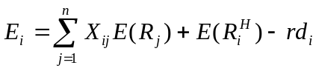 (2)
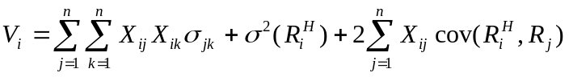 (3)
where E_{i} is the expected return of individual i’s total assets
E(R_{j}) is the expected return on firm j held by individual i,
R^{H} is the return on human capital
d_{i} is the net debt of individual i,
X_{ij} is the weight on security j held by individual i
The individual wants to maximizes his utility of expected return:
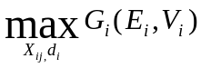 (4)
subject to the budget constraint:
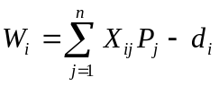 (5)
where W_{i} is the total wealth of individual i,
P_{j} is the total market value of firm j at the beginning of the period.
Using the Lagrangian equation to solve the maximization problem, we obtain:
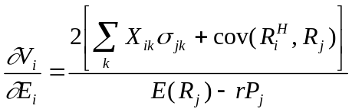 (6a)
Equation (6a) shows that investor’s marginal rate of substitution between risk and return is determined by:
- The covariance of investor’s human capital and the return on security j.
- The sum of covariance of all outstanding securities in the market portfolio.

The inverse of equation (6a) is the required marginal rate of return per unit of variance (risk) for individual i. As the covariance of investor’s human capital and the return on security j decreases, individual’s marginal rate of return per unit of risk increases, given the expected return on security j unchanged. Therefore, by holding a negative-correlation asset with one’s human capital, one can increase his marginal return per risk. It explains why an individual should hold an asset with negative correlation to his human capital because the negative correlation provides a hedge and also increase the marginal rate of return for a given level of risk.

In addition, as the sum of covariance of all outstanding securities in the market portfolio decreases, the marginal rate of return per unit of risk increases. Therefore, people should hold securities that have low covariance.

From 6(a), we can further solve the optimal weights of all assets for individual i:
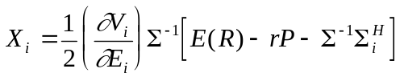 (6b)
where 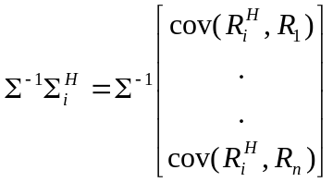 Equation (6b) shows that the optimal weight on the market portfolio is not identical for every investor. In contrast to the SLM’s model, which suggests that the optimal weight is simply 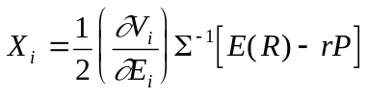. Equation (6b) suggests that the optimal weights for any individual depends on the covariance of individual i’s human capital return to the return of securities 1,2…n. Individuals may hold different proportions of risky securities and may invest in different securities, they will take into consideration the covariance of their human capitals to each risky security.

Implications of equation (6b) are:
a) The lower the covariation with risky security x to individual’s human capital, the more weight the individual will place on security x. For example, if a person works for a biotech company and holds a large amount of stocks of that company as his compensation, he or she will hold a greater proportion of securities that have negative correlations with the biotech company as a hedge. If the stock price of the biotech company declines, those securities with negative correlations will offer positive returns. Therefore, the increased weights in these hedging securities change the optimal weight of the market portfolio for this individual. This concept is illustrated in figure 1 and 2:

Figure 1 shows that if human capital is considered in the asset allocation decision, individual i will hold three assets: stock of biotech firm (represents his human capital), a hedging portfolio against the human capital, and a market portfolio 1 which is identical for all investors. If we incorporate the hedging portfolio into the market portfolio, as shown in Figure 2, the weight on the optimal market portfolio for this individual changes, different investors hold different market portfolios. Therefore the market portfolio in figure 2 is different for different investors. This explains why in reality different investors do not hold identical assets as suggested by the SLM model.
Figure 1: Figure 2:
Biotech

Biotech

Hedging portfolio
Market Portfolio 2
Market Portfolio 1

b) The systematic risk of individual i’s human capital is represented by 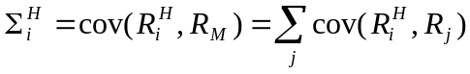 (7)
Therefore, the larger the covariance between one’s human capital to the market portfolio, the smaller the optimal weight on risky securities. This result supports the findings of Bodie, Merton, and Samuelson (1992). They develop a stochastic wage model and find that the riskier an individual’s human capital, the lower his financial investment in risky assets.
For instance, for a CEO who works for ebay and holds a large proportion of stock option as his compensation, he might not want to allocate most of the rest of his wealth on stocks, and would rather invest in T-Bills.
Next, we obtain risk-return relationship from above equation:
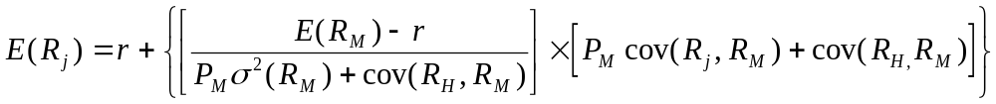 (8)
Assume that the total value of future human capital P_{H} is observable (this assumption is reasonable since we can use wage (w) times labor (L) to measure the P_{H}, the current value of future human capital.) Then equation (8) becomes
where the risk can be expressed as 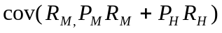 (9)

Equation (9) yields an important result: market risk for security j is determined by the comovement of the j’s return with the return to all assets, including financial assets and human capital assets.

Equation (9) can also be written in terms of β:
E(R_{i}) = r+ β*risk premium, where
β_{j}=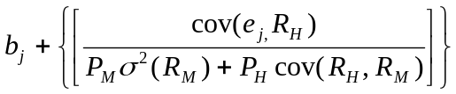 (10)
where b_{j} is the original beta in the traditional SLM model
The extra term in equation (10) stands for an extra systematic risk caused by the covariance between human capital asset and the firm-specific risk of the jth firm.

Implication of equation (10):
- Security j’s modified beta has an extra element: 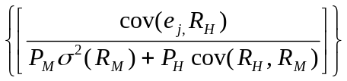. As the covariance between security j’s firm-specific risk and one’s human capital increases, modified beta increases, i.e. the required rate of return for security j increases. The individual will ask for a higher rate of return for a given level of risk.

- If we use wages times labor (working years) to measure the value of human capital, P_{H}, then P_{H} = wages*labor. Two relationships exist:

First, as wages increases, the modified beta decreases. Namely, given other parameters constant, we can think of higher wage as larger intensity of work. Larger intensity of work decreases the required return on risky security j.
Second, as working year increases, the modified beta decreases. Longer length of work also decreases the required return on risky security j.

These two results together yield a conclusion: as labor becomes more flexible (longer length of work or larger intensity of work), risky security’s beta decreases, causing a lower required rate of return for this security. It implies that the individual with more flexible labor becomes more risk-tolerant. This result is similar to the findings of Bodie, Merton, and Samuelson (1992). They report that as labor supply becomes more flexible, people will assume greater risks in their investment portfolio.

III. Real Estate Asset
Consider that an individual includes a real estate asset in his portfolio. Then the individual’s portfolio consists of three assets: 1) Risky market portfolio, 2) Human capital, and 3) Real estate asset. The return of individual i is then given by:
(11)
where R is the total rate of return
X^{R} is the weight on risky market portfolio
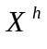 is the weight of total wealth on house
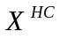 is the weight of total wealth on human capital
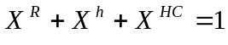
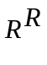 is the return on risky market portfolio,
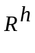is the return on the house,
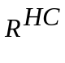 is the return on human capital,

Then the expected return and variance of the individual’s total assets are:
(12)
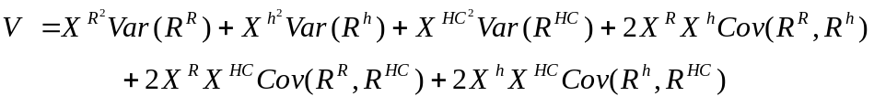 (13)
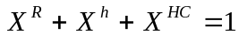 (14)
The individual wants to maximize his utility function 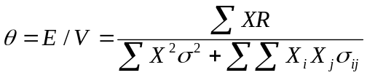 subjected to the budget constraint (14):

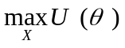 (15)

Use Lagrangian equation to solve the maximization problem:
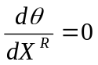
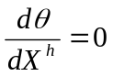
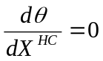

We obtain:
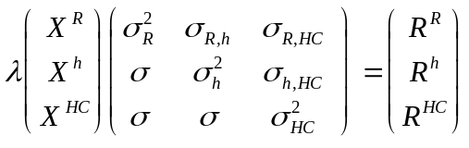, where is the Lagrange multiplier

Then, the optimal weight for risky security, house, and human capital is:
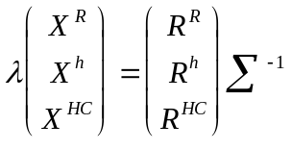 (16)
where Σ= 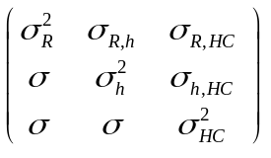,the variance-covariance matrix of three assets.

Therefore, the optimal weight for each asset is determined by its return, its variance, as well as its covariance with the other two assets.

Further, if the covariance between the house and the risky security is low, the proportion of total asset in a house will be higher, i.e. investor can buy a larger house. The reason is that the optimal weight on a house is a function of the covariance between the house and the risky securities, the covariance between the human capital and the house, and the covariance between the human capital and risky securities. The smaller these covariances are, the larger the weight on the house.

Take a closer look at the expected return per unit of risk:
(17)
The smaller the covariance among assets, the higher the expected return per unit of risk, other things equal. Therefore, an investor should buy a house with low comovement with his human capital and with his risky securities in order to increase his return/risk.

Numerical Example:
To illustrate the effect of the covariance between assets, consider the following hypothetical setup:
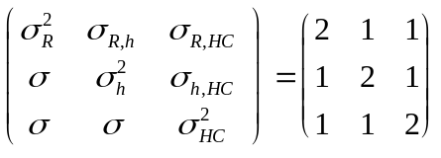, 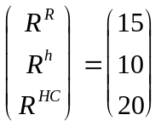
Then the optimal weights are 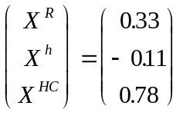.

- Effect of Return:
The effect of return on optimal weight is obvious: the higher the return of an asset, the larger the weight on that asset. If an individual has high human capital return, he or she should invest more of his/her wealth on human capital.

- Effect of covariance:
A.) The following setup illustrate the effect of high covariance between one’s human capital and house:
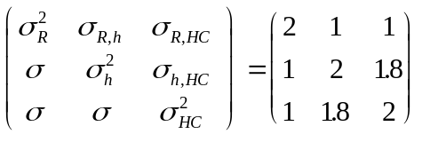,
Then the optimal weights are 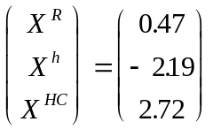. When there is high covariance between one’s human capital and house, if the return on human capital is larger than that of the house, the optimal weight on human capital (2.72) is much more than the optimal weight in previous case (0.78), and the optimal weight on house (-2.19) is much less than the optimal weight in previous case (-0.11).

B) When there is low covariance between stocks and house, one will increase the investment on house because of its low correlation with stock market. Following is the numerical evidence:
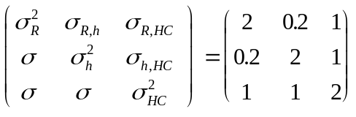
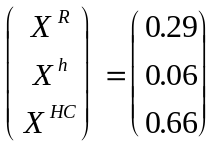
The optimal weight on house increases from –0.11 (in the first case) to 0.06.

- Effect of variance:
If human capital has high return and high covariance, (other things equal), then the optimal weight on human capital is:
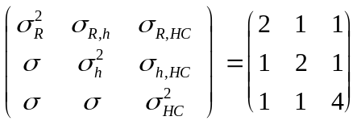
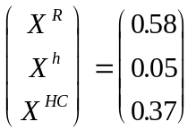 The optimal weight on human capital becomes less (0.37 compared to 0.78 in the first case) due to higher variance of human capital.

Empirical Issues and Discussion:
Many studies have emphasized the diversification effect of real estate to investors’ portfolios. In particular, the comovement between investor’s stock portfolio and real estate asset have been analyzed empirically. Grauer and Hakansson (1995) report that there are gains from diversifying into real estate. They study the impact of adding real estate asset to different stock portfolios such as passive stock portfolio, active stock portfolio, and global stock portfolio, and conclude that there are gains of adding real estate asset due to its low correlation with stock market. Quan and Titman (1999) report that although existing studies find low correlation between real estate and stock price indexes, they discover a significant relation between stock returns and both rents and real estate price changes when using a pooled data across countries and with a longer time intervals. They also find that real estate is a good long-term hedge against inflation but a poor year-to-year hedge. They conclude that there is indeed a low correlation between stocks and real estate in short-term horizon, but when measured in a long-term basis, the correlation between stocks and real estate is significant. Tracy, Schneider and Chan (1999) study the impact of bull stock market since 1990 to household’s asset allocation. They report that the proportion of households that own equity rose from 32 percent in 1989 to 42 percent in 1995, due to the high return provided by a bull stock market. However, most families remain heavily invested in housing, tying up a full two-thirds of their assets in real estate. Shiller and Weiss (forthcoming) recommend that trading on metropolitan house price indexes can diversify the risk associated with local housing market price.

There are very few empirical studies that analyze the diversification effect of human capital in household portfolios, mainly because it is hard to measure and collect the data of covariance between human capital and real estate asset, or covariance between human capital and stock market. Theoretical model suggest that there is a diversification effect of human capital, and investor should consider the correlation of human capital with other assets, when making investment decisions.

Effect of Housing Location: The covariance of house and human capital can be captured by the location of house. The farther the distance between one’s home and work, the smaller the covariance is. The individual is compensated by lower comovement of his house to his human capital, and probably cheaper housing price. On the other hand, the individual has to pay extra commuting expense. Turnbull, Glascock, and Sirmans (1991) establish a model that relates uncertain income with housing price and location. They suggest that household responds to increases in pure income risk by consuming less housing closer to the central business district. In addition, the expected housing price is a decreasing convex function of distance from the central business district.

Effect of Short Sell Constraint: The model discussed above assumes that there is no short-sell constraint on any asset, i.e. one can short sell his human capital or house. However, in reality, people do not short sell their human capital, and most people do buy a house if they can afford it, the difference is when to buy the house in their life cycle. Therefore, it is reasonable to place constraints for human capital and house in the model. For example, we can assume that people always buy a house, and the maximum amount that normal people allocate to his house is 2.5 times his human capital, measured by annual income, and the minimum weight on a house is 20 percent of his portfolio. Then we can perform sensitivity analysis and see the impact of covariance, variance, and return of three assets on investor’s portfolio, under constraints.

Conclusion
This paper studies the impact of human capital and real estate asset on asset allocation. It incorporates human capital asset and real estate asset into the traditional mean-variance model. The covariance between human capital, house, and risky asset play a significant role in asset allocation. The impact of human capital to asset allocation problem is as follows: When people’s human capital has a low correlation with the market portfolio, they will assume greater risks in their investment portfolio. By holding a negative-correlation asset with one’s human capital, one can increase his marginal return per unit of risk. In addition, if an individual’s labor supply becomes more flexible, he or she will be more risk-tolerant. When a house is added in an investor’s portfolio, the investor should consider the comovement of the house to the rest of his assets, and buy a house with low covariance with his personal human capital and risky securities in order to maximize his total rate of return per risk. If the individual’s human capital is highly correlated to his house, he should invest less in the house. The model can be further expanded by adding location into the maximization problem, or by adding short-sell constraints of certain assets.

Reference:
Bodie, Merton, and Samuelson (1992), “Labor supply flexibility and portfolio choice in a life cycle model.” Journal of Economic Dynamics and Control, 16, 1992, 427-449

Granuer, Robert R., and Nils H. Hakansson (1995) “ Gains from diversifying into real estate: Three decades of portfolio returns based on the dynamic investment model.” Real Estate Economics, Vol. 23, Issue 2, 1995

Lintner, J. (1965), “The valuation of risk assets and the selection of risky investments in stock portfolios and capital budgets,’ Review of Economics and Statistics, February 1965, 13-37

Mayers, D. (1972) “Nonmarketable assets and capital market equilibrium under uncertainty”. Studies in the theory of capital markets (Praeger, New York, NY) 223-248

Mossin, J. (1966), “Equilibrium in a capital asset market,” Econometrica, October 1966, 768-783

Quen, Daniel, and Sheridan Titman (1999) “Do real estate prices and stock prices move together? An interesting analysis.” Real Estate Economics, vol. 27, issue 2, 1999 183-208

Sharpe, W.F. (1964), “Capital asset price: a theory of market equilibrium under conditions of risk.” Journal of Finance, September 1964, 425-442

Shiller, Robert, and Allan Weiss (forthcoming), “Home equity insurance.” Journal of Real Estate Finance and Economics.

Tracy, Joseph, Henry Schneider, and Sewin Chan (1999) “Are stocks overtaking real estate in household portfolios?” Current Issues in Economics and Finance, Vol. 5, Number 5, April 1999. Federal Reserve Bank of New York.

Turnbull, G.K., John L. Glascock, and C.F. Sirmans (1991), “Uncertain income and housing price choice.” Journal of Regional Science, 1991, 417-431

